9. Jesus and the Judgment
1-2 Kings
2 Corinthians 5:21
10. Jesus and the Prophets
Isaiah, Ezekiel, Jeremiah, Daniel
2 Corinthians 1:20
11. Jesus and the Temple
Ezra, Nehemiah, Haggai
Zechariah 4:6-7
John 2:19
12. Jesus and the New Covenant
Jeremiah 31:31-34 --> Hebrews 8
13. Jesus and the New Creation
Revelation 21-22

Overview of the Entire Bible Schedule
Week 1 – Content Overview of the Entire Bible
Week 2 – Storyline Overview of the Entire Bible
Week 3 – Jesus in the Old Testament
Week 4 – Pentateuch, Part 1 (Genesis 1-11)
Week 5 – Pentateuch, Part 2 (Genesis 12 – Deuteronomy)
Week 6 – Historical Writings, Part 1 (Joshua – 2 Samuel)
Week 7 – Historical Writings. Part 2 (1 Kings – 2 Chronicles)
Week 8 – Historical Writings, Part 3 (Ezra – Esther)
Week 9 – Poetry (Job – Song of Solomon)
Week 10 – Prophets (Isaiah – Malachi)
Week 11 – Gospels & Acts (Matthew – Act)
Week 12 – Letters & Revelation (Romans – Revelation)

For any questions, email bnistor@sheridanhills.org.

Core Seminars—Overview of the Entire Bible
Class 3: Jesus in the Old Testament

“Do your best to present yourself to God as one approved, a worker who has no need to be ashamed, rightly handling the word of truth.” (2 Timothy 2.15)

A. What is the Old Testament About?
1. Jesus’s Answer:
Luke 24
2. Peter’s Answer:
1 Peter 1
3. Paul’s Answer:
2 Timothy 3
4. John’s Answer:
John 5
5. Hebrew’s Answer:
Hebrew 1:1-3
6. The Gospels
Matthew 1
Mark 1
Luke 1
John 1

B. Two Approaches to the Old Testament
1. Non-Christian Approach to the Old Testament
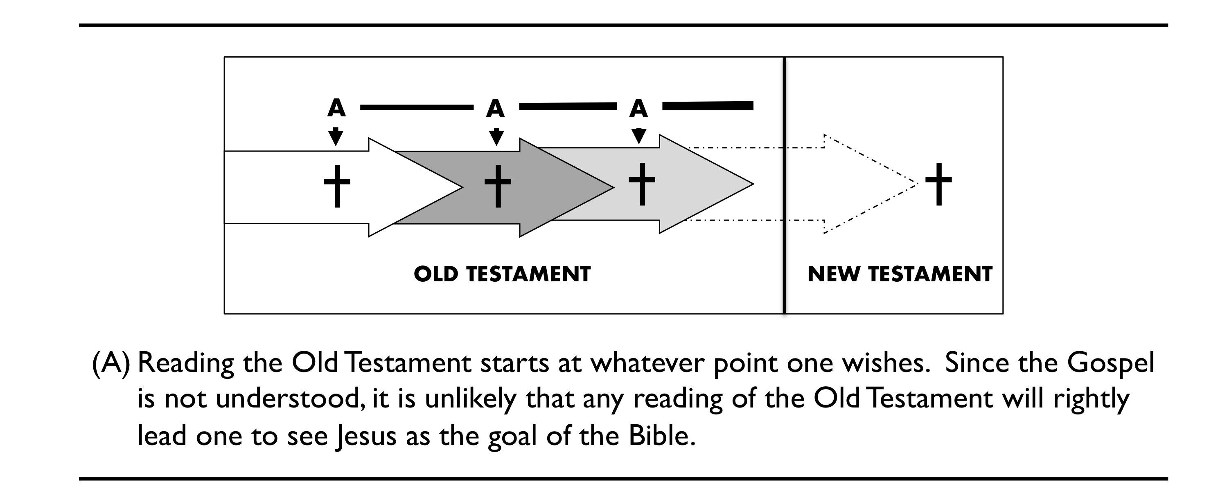
2. Christian Approach to the Old Testament
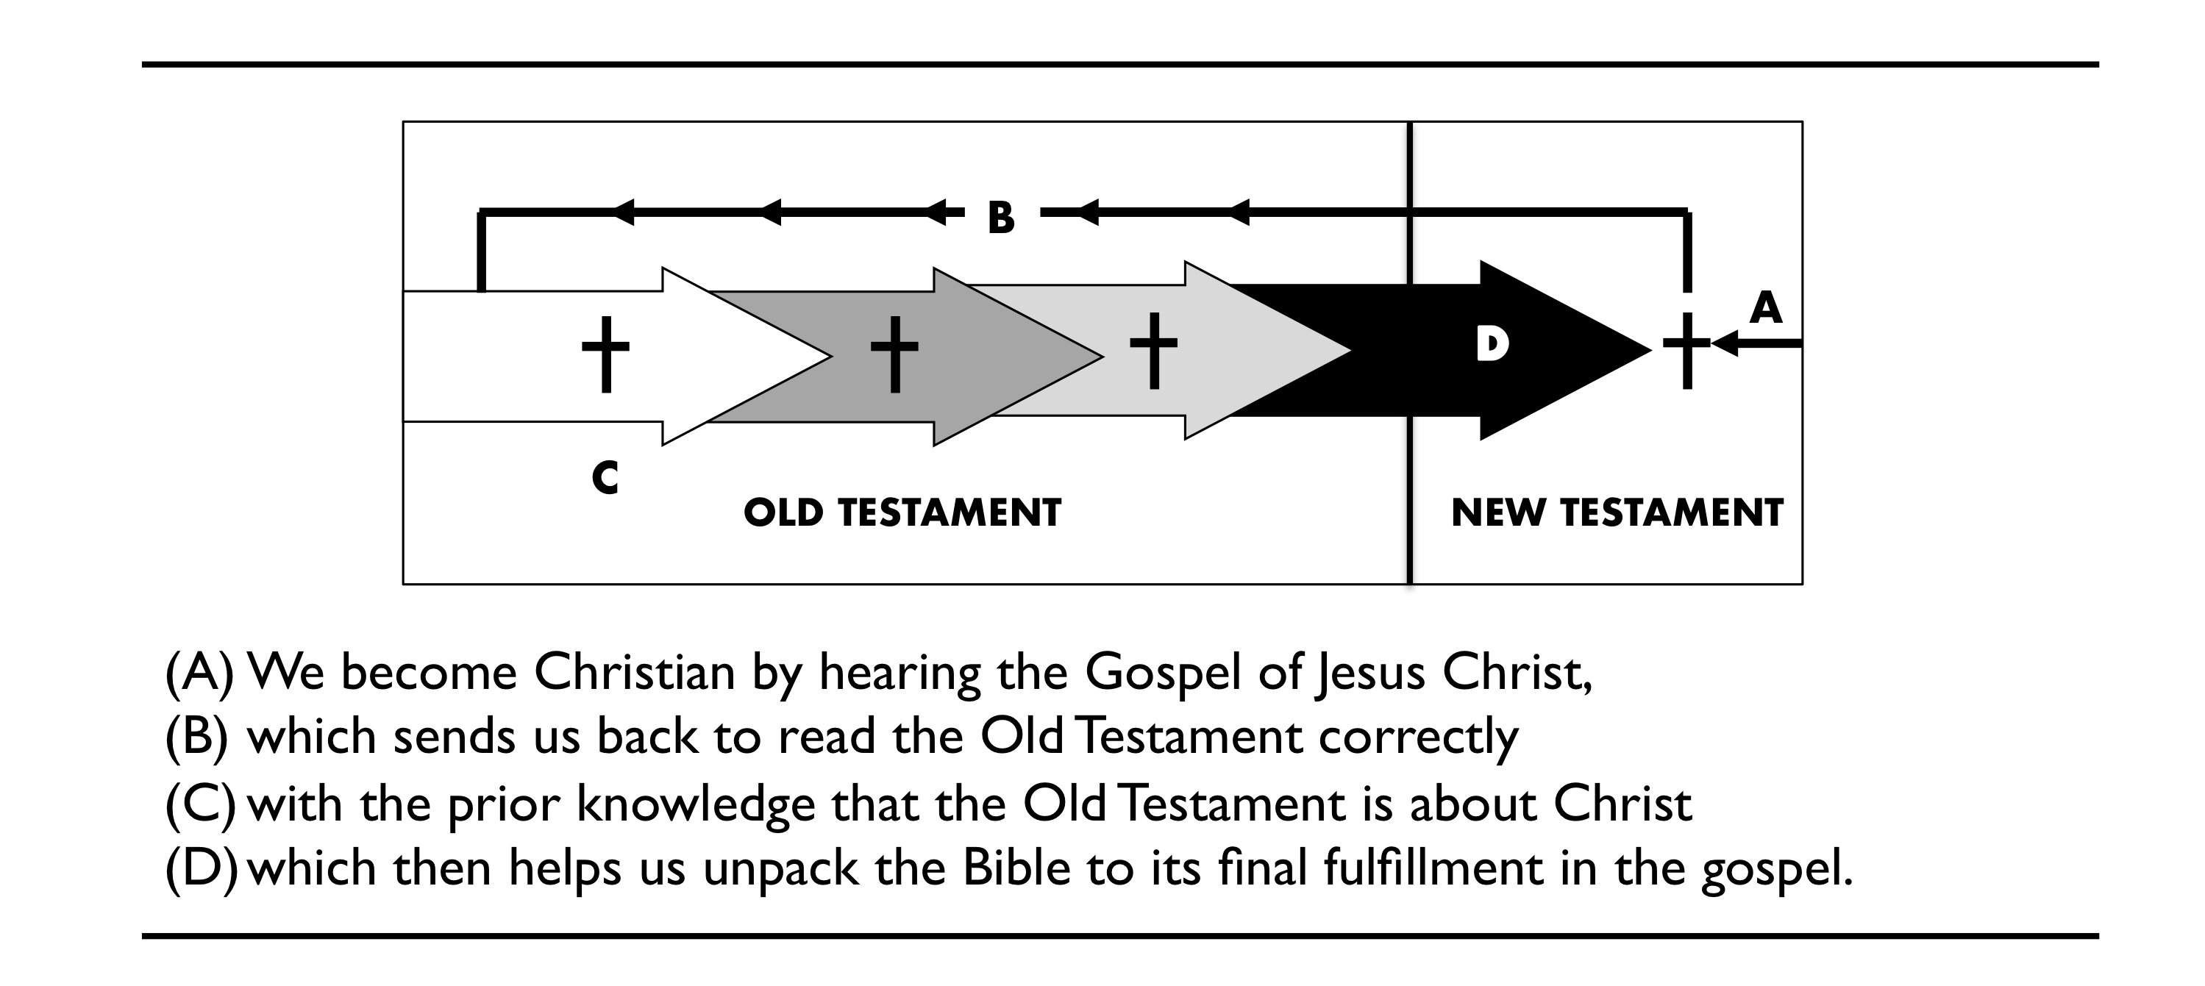

C. Examples of Jesus in the Old Testament
1. Jesus and Adam
Genesis 1-3
1 Corinthians 15
Romans 5

2. Jesus and the Fall
Genesis 3:15
Romans 16:20
3. Jesus and Abraham
Galatians 3
Romans 4
4. Jesus and the Exodus
Exodus 15
Revelation 15
5. Jesus and the Law
Exodus 20
Leviticus
Matthew 5:17
2 Corinthians 2:7-18
6. Jesus and the Sacrifice
Leviticus
Hebrews 10:11-14
7. Jesus and the Promised Land
Joshua, Judges, Ruth
Hebrews 4:1-13
8. Jesus and the Kingship
Deuteronomy 17:14-20; 2 Samuel 7; 1 Kings 8
Acts 2:29-33; Matthew 22:41-46 --> Psalm 110:1

