Ezekiel

Daniel

Minor Prophets

Gospels

Letters

Revelation

Overview of the Entire Bible Schedule
Week 1 – Content Overview of the Entire Bible
Week 2 – Storyline Overview of the Entire Bible
Week 3 – Jesus in the Old Testament
Week 4 – Pentateuch, Part 1 (Genesis 1-11)
Week 5 – Pentateuch, Part 2 (Genesis 12 – Deuteronomy)
Week 6 – Historical Writings, Part 1 (Joshua – 2 Samuel)
Week 7 – Historical Writings. Part 2 (1 Kings – 2 Chronicles)
Week 8 – Historical Writings, Part 3 (Ezra – Esther)
Week 9 – Poetry (Job – Song of Solomon)
Week 10 – Prophets (Isaiah – Malachi)
Week 11 – Gospels & Acts (Matthew – Act)
Week 12 – Letters & Revelation (Romans – Revelation)

For any questions, email bnistor@sheridanhills.org.

Core Seminars—Overview of the Entire Bible
Class 1: Content Overview of the Entire Bible

“Do your best to present yourself to God as one approved, a worker who has no need to be ashamed, rightly handling the word of truth.” (2 Timothy 2.15)

- Why an overview of the entire Bible?

- To sharpen biblical literacy
- To view biblical history as our history
- To make sense of the world through the Word
- To gain a deeper desire for God
- To understand human nature more profoundly
- Structure of the Bible
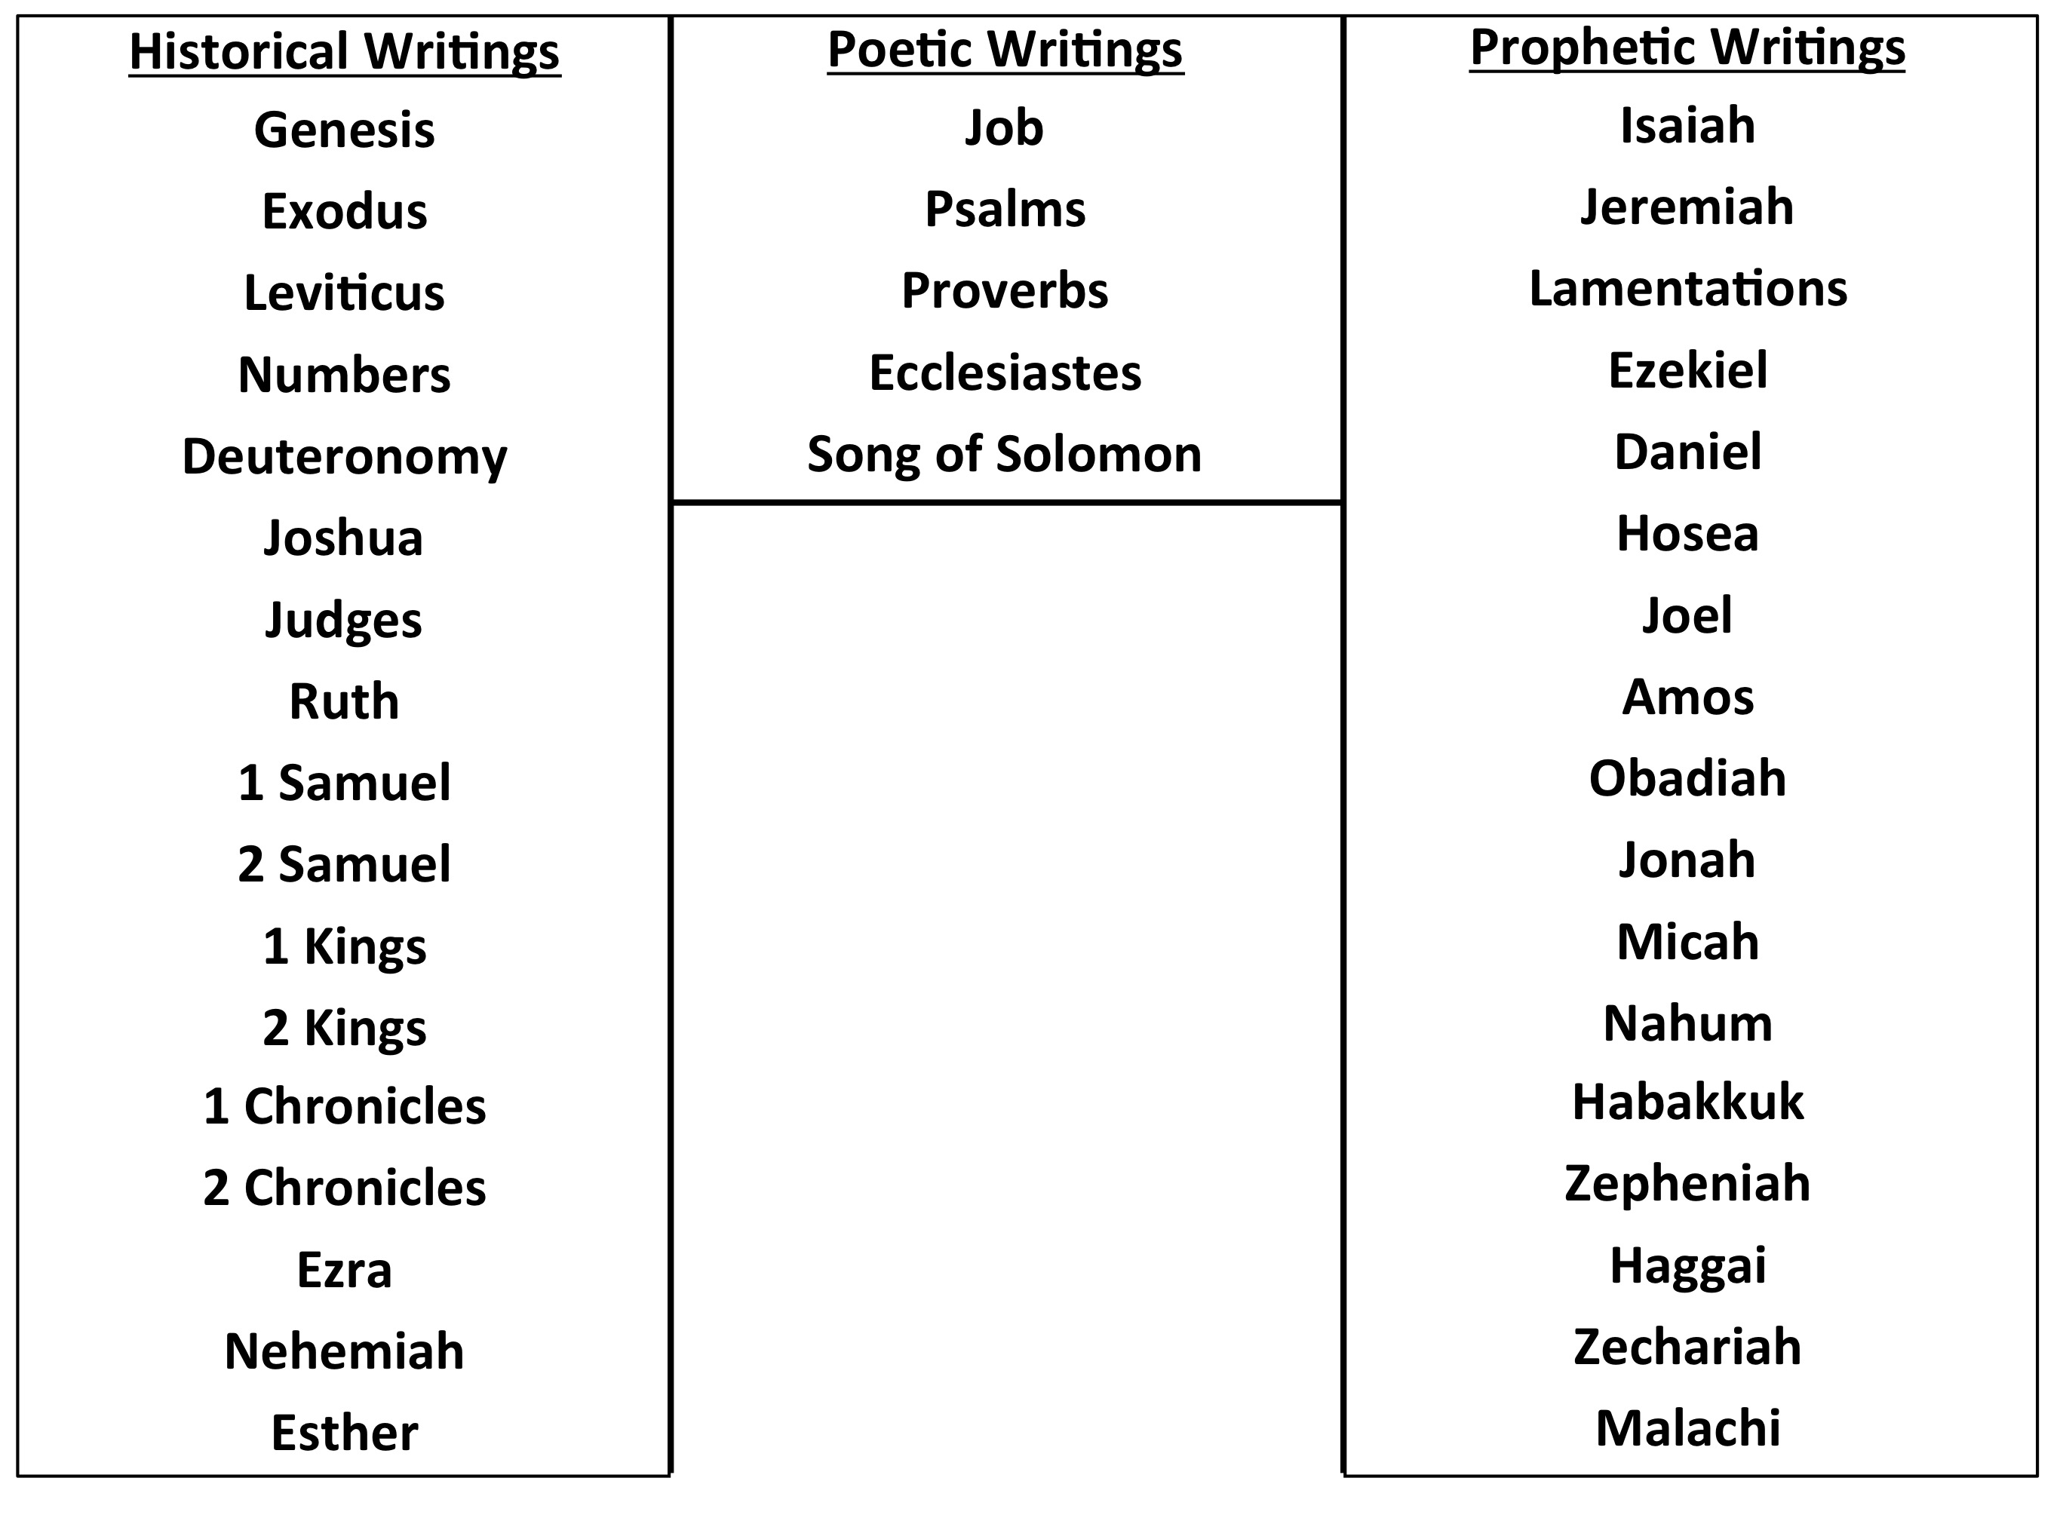
  - Old Testament

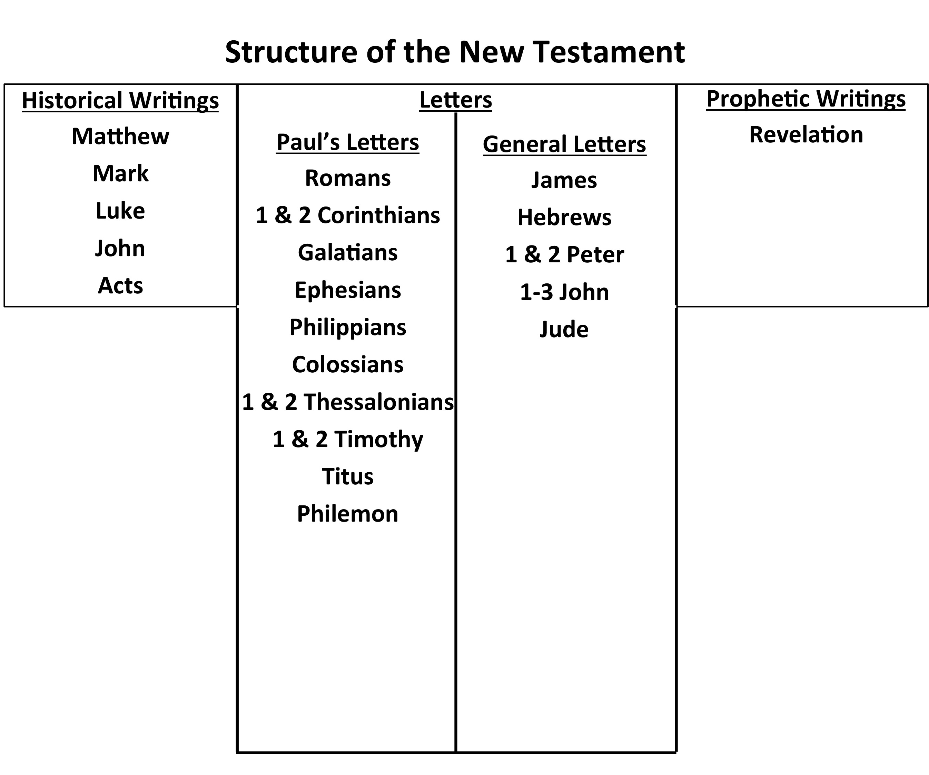
  - New Testament

- Book-by-Book Overview
Genesis

Exodus

Leviticus

Numbers

Deuteronomy

Joshua

Judges

Ruth

1 & 2 Samuel

1 & 2 Kings

1 & 2 Chronicles

Ezra & Nehemiah

Esther

Job

Psalms

Isaiah

Jeremiah & Lamentations

